2R Robotic Arm Animation using MATLAB:

This is an animation code of simulating the forward kinematics of a 2R Robotic Arm using MATLAB.

A 2R Robotic Arm is double hinged component consisting of two links and with 4 degrees of freedom.

It is one of components used to do complex automatic things such as handling, welding etc. using various interchangeable tools namely manipulator, drill bit etc.

The skeleton view of the arm is attached below:

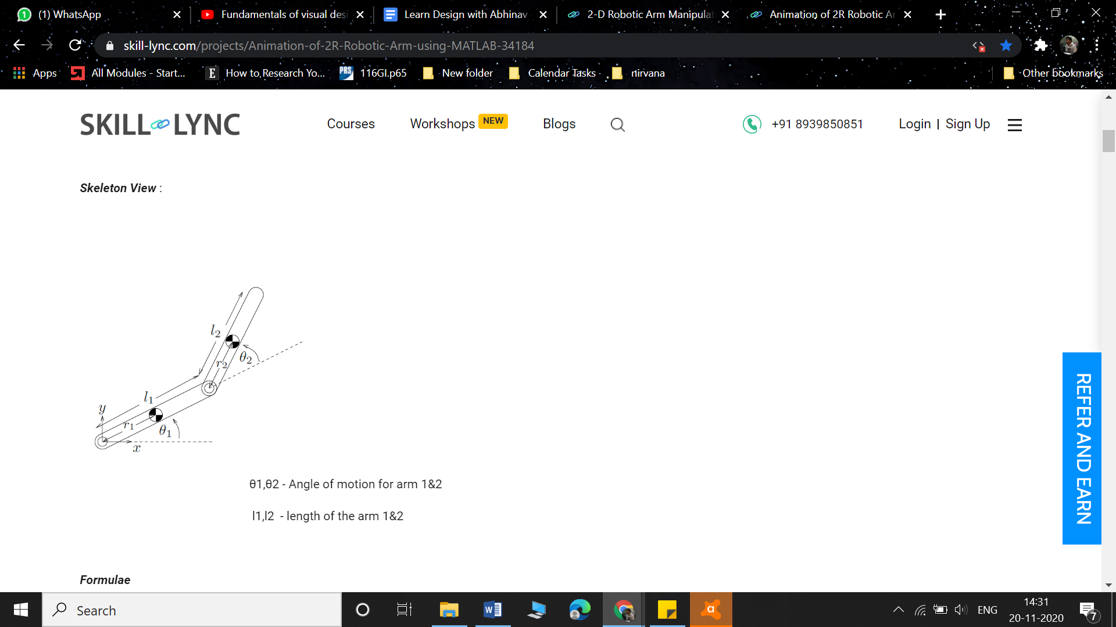

Source: Google Images

Here, l1 and l2 are lengths of arm 1 and 2 while θ 1 and θ 2 are angles of rotation of the arms respectively.

To find the co-ordinates of the (x,y) points, below mentioned formula is used:

         x1 = l1 cos θ1     ;     y1 = l1 sin θ1

         x2 = l2 cos θ2     ;    y2 = l2 sin θ2

The proper commented code file has been attached in the folder.

Thus, the computational working simulation is done through providing different angles on both the arms by coding in MATLAB and bringing out the working space/range of the Robotic arm by visual representation i.e. animating a video.

https://dare2compete.com/job/software-internship-cardekhocom-247269